OIO Service Oriented Infrastructure

OIOSI RASP Library for .Net RC1
Installation Guide
Contents
1 Introduction 3
2 System requirements 3
3 Install Package 4
4 Installing 4
4.1 External Libraries 4
4.1.1 Microsoft .Net 2.0 4
4.1.2 Microsoft .Net 3.0 4
4.1.3 Microsoft Windows SDK and Visual Studio Extensions for .Net 3.0 5
4.2 Certificates (for running test applications) 5
4.2.1 The TDC CSP 5
4.2.2 Importing the certificates 5
4.3 NUnit (for running the NUnit sample test) 7
4.4 Test endpoints 7
5 Verifying Installation 7
6 Uninstalling 7

Introduction

The OIOSI RASP Library for .Net is a Microsoft .Net based toolkit for implementation of RASP (Reliable Asynchronous Secure Profile) compliant business applications.

This distribution is Release Candidate 1 (RC1).

The distribution is part of the OIOSI work for exchanging business documents in a secure and reliable way using the internet, see http://www.oio.dk/arkitektur/soa/infrastruktur for more information.

This document describes the steps needed before the RASP Library can be built and used.

The library can be downloaded from

http://softwareborsen.dk/projekter/softwarecenter/serviceorienteret-infrastruktur/rasp-library-for.net/releases/1.0rc1

System requirements

- Microsoft Windows XP professional or Microsoft Windows Server 2003, including the latest service packs
- Microsoft Internet Information Services 5.0 or later
- Microsoft Visual Studio 2005
- Microsoft .Net 2.0 Framework
http://www.microsoft.com/net/
- Microsoft .Net 3.0 Framework
http://www.microsoft.com/net/
- Microsoft Windows SDK for .Net 3.0
http://www.microsoft.com/downloads/details.aspx?FamilyId=C2B1E300-F358-4523-B479-F53D234CDCCF&displaylang=en
- Visual Studio Extensions for .Net 3.0
http://www.microsoft.com/downloads/details.aspx?FamilyId=F54F5537-CC86-4BF5-AE44-F5A1E805680D&displaylang=en
- Port 80 (HTTP) open
- Port 8080 must be free (used for hosted service tests with NUnit)

To host your own RASP mail service you will also need

- Access via POP3 and SMTP to a mail inbox (exclusively used for this purpose) per endpoint (both server and client side). Furthermore the mail server (and its spam filters) should not scramble or discard attachments of MIME type application/soap+xml
- Port 25 (SMTP) open

To run the test applications (and LesnikowskiImplementation.dll) you will also need

- The test certificate pack
(found in the RaspLibrary project folder under Resources\)
- Lesnikowski mail library
www.lesnikowski.com/mail/

Install Package

The RASP Library RC1 is distributed as a zip file, which should simply be unzipped into any folder.
Note that projects within the release pack cannot be moved from their internal paths relative to each other. If so, library references must be updated.

There are 2 solutions:

- RaspClientSource
This solution holds the library and utility component code
- RaspClientTests
Holds all standalone and NUnit tests

Installing
This section will take you through the necessary steps for installing the pre-requisites and the RASP Library.

External Libraries
The following section describes what external libraries are needed to run the RASP Library.

Microsoft .Net 2.0
The RASP Library runs on the Microsoft .Net 2.0 platform, wherefore the runtime library needs to be installed. It can be found at
http://www.microsoft.com/net/

or a direct link to the download page
http://www.microsoft.com/downloads/details.aspx?familyid=0856eacb-4362-4b0d-8edd-aab15c5e04f5&displaylang=en

Microsoft .Net 3.0
The RASP Library uses Windows Communication Foundation, wherefore the .Net 3.0 runtime library needs to be installed. It can be found at
http://www.microsoft.com/net/

In case you have had an earlier version of the RASP Client or WinFx (.Net 3.0 pre-release) make sure you follow the un-installation instructions at the download page.
This release of the RASP Library has been tested using the first release of .Net 3.0 (November 2006) that can be found at:
http://www.microsoft.com/downloads/details.aspx?FamilyId=10CC340B-F857-4A14-83F5-25634C3BF043&displaylang=en

Microsoft Windows SDK and Visual Studio Extensions for .Net 3.0
To fully be able to use the RASP Library test projects, and for example examine the log files generated Windows SDK and Visual Studio Extensions for .Net 3.0 should be installed.

Microsoft Windows SDK for .Net 3.0 can be found at:
http://www.microsoft.com/downloads/details.aspx?FamilyId=C2B1E300-F358-4523-B479-F53D234CDCCF&displaylang=en

and Visual Studio Extensions for .Net 3.0 at:
http://www.microsoft.com/downloads/details.aspx?FamilyId=F54F5537-CC86-4BF5-AE44-F5A1E805680D&displaylang=en

Certificates (for running test applications)
The OIOSI RASP Library comes with a test certificate pack that can be found under the RaspLibrary project subfolder Resources\Certificates\

The TDC CSP
The TDC CSP (Crypto Service Provider) may be installed on the client computer and used for client side certificates, but depending on the installation order, this may give rise to issues when running the server side functionality. The client certificate may be under control of the TDC CSP, but the server functionality (i.e. the ability to receive mails initiated by external message senders) requires the server certificate (TDC virksomhedscertifikat) to not be under control of the TDC CSP. You may remove the server side certificate from the control of the CSP, this is in line with the certificate policies for ”virksomhedscertifikater”, provided that sufficient protection is given to the executing application.

In order to achieve this, the TDC CSP must not be installed while importing the server side certificate. Therefore you should uninstall the CSP before importing the certificate – you can do this in ”control panel – add/remove programs”. After you have imported the server side certificate, you may re-install the CSP. The latest CSP can be downloaded here:

https://bestilling.certifikat.tdc.dk/csp/authenticode/csp.exe

Importing the certificates
You need to install a root certificate, a server side certificate, and a client side certificate before you run the client. The RASP Library test projects use the same certificate for both the server and the client. The certificates can be found in a subfolder to the RaspLibrary project folder called Resources\Certificates.

Note that you may want to use other certificates that then ones included in the test client. In this case you can follow the directions below, but use your own certificates instead. In this case you may need to install more than one root certificate. Also remember, that in the prototype you need to manually install the certificates of the remote endpoint.

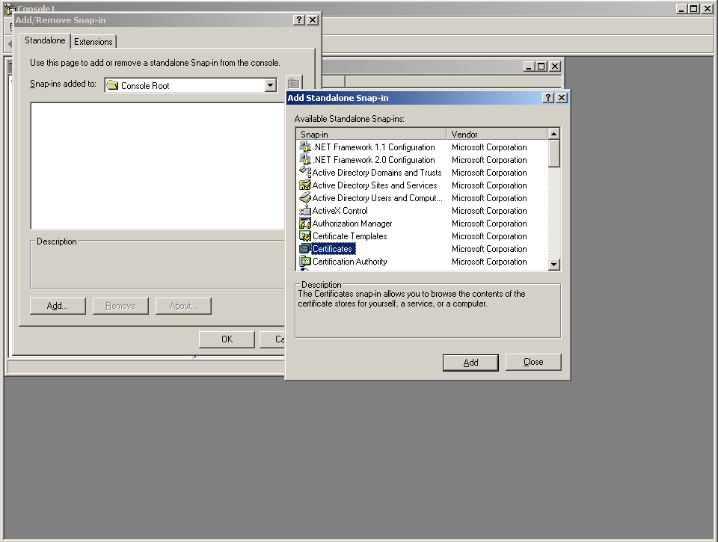
- Start a Microsoft Management Console
Start->Run->”mmc”
- Add two snap-ins, File->Add/Remove Snap-ins…
Under Standalone, choose “Add…”
- Choose ”Certificates”
“This snap-in will always manage certificates for”, choose “My user account”
- Do step 3 and 4 again, but choose ”Computer account” this time.
When asked what computer to handle, choose ”Local computer”
- In the console window, select “Certificates (Local Computer)”/Trusted Root Certification Authorities/”
- In the menu, choose Action/All tasks/Import…
- When asked what file to import, find the certificate file ”TDCTestRoot.cer”
- Password for the private key: ”Test1234”, choose “Enable strong private key protection”
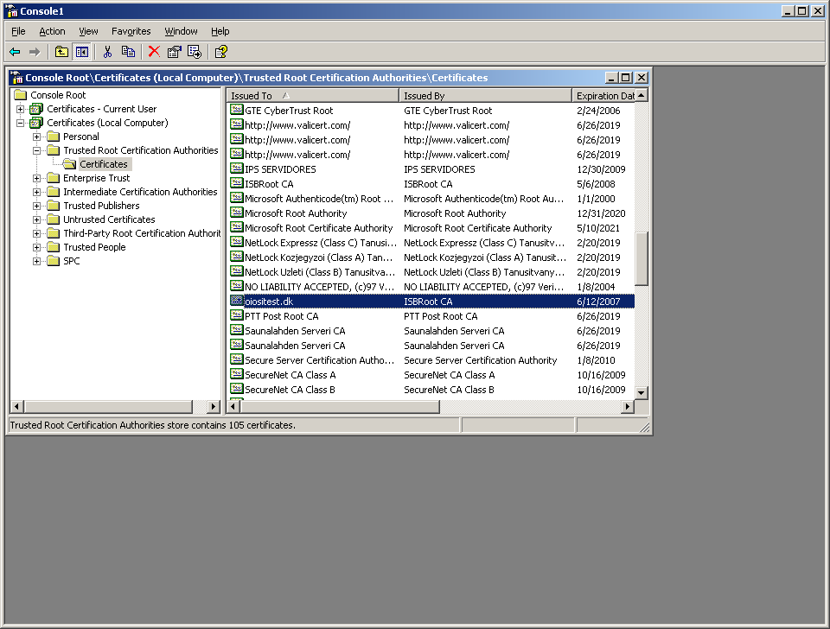
- Choose “finish”

- In the menu, choose Action/All tasks/Import…

- When asked what file to import, find the certificate file ” OiosiTestVoces2.pfx”. Password is “Test1234”
- In the console window, go to ”Certificates – Current user”/Personal/Certificates”
- In the menu, choose Action/All tasks/Import…

- When asked what file to import, find the certificate file ” OiosiTestVoces2.pfx”. Password is “Test1234”

NUnit (for running the NUnit sample test)
To run the NUnit test dll located in the RaspClientTests, NUnit needs to be installed locally on the machine. When installed the framework can be used to run NUnit tests and develop tests in Visual Studio. Follow the two simple steps to install NUnit:

- Download the newest install version of NUnit for .Net 2.0 from www.nunit.org.
- Install the downloaded file.

Now NUnit tests can be executed from NUnit which is located under
“start/all programs/NUnit.Net-version/NUnit.Net-version”.

Test endpoints
Test endpoints can be found at the following location:

http://oiositest.dk/interoptest/oiosiOmniEndpointB.svc
Endpoint with RM and security

http://oiositest.dk/InteropTest/OiosiOmniEndpointA.svc
Endpoint with RM and security

http://oiositest.dk/InteropTest/OiosiOmniEndpointPlain.svc
Endpoint without RM and security

http://oiositest.dk/InteropTest/OiosiOmniEndpointNoSecurity.svc
Endpoint with RM only

Verifying Installation
To verify that the setup of the library has been done correctly it is recommended that one compiles the RaspClientTests solution and, tries running one of the test projects such as TestRequest, or that the NUnitTestRaspLibrary project is compiled and run in NUnit.

Uninstalling
Uninstalling the RASP Library is done by simply deleting the folders into which the library was unzipped.

